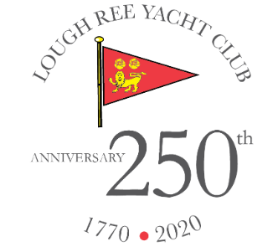

International J24 Class Association of Ireland Western Championships

Lough Ree Yacht Club
Ballyglass, Hillquarter, Coosan, Athlone, N37 K257

Saturday 29th & Sunday 30th April 2023

Withdrawal of issued Sailing Instructions (SIs)

The SIs for the event previously issued have been withdrawn from circulation and should be ignored.

Amendment to NOTICE OF RACE (NoR) 2

Nor 4 is amended to read
“SIs will be made available online at
J24 Ireland https:///j24ireland.ie
L,R.Y.C. https://www.lryc.ie/event/j24-westerns-2/ and on the event WhatsApp on or before Friday 28th.

Printed versions will also be available at registration

22/04/2023 18124

